(Excel project)

Name of Project :- “Store Data Analysis”

Data Source :- Mentor has provided on google drive

File extension :- .xlsx

No. of Rows :- 31,048

No. of Fields :- 19

Objective :-

Vrinda store wants to create an annual sales report for 2022. So, that Vrinda can understand their customers and grow more sales in 2023.

Questions :-

* Compare the sales and orders using single chart.
* Which month got the highest sales and orders?
* Who purchase more - men or women in 2022?
* What are different order status in 2022?
* List top 10 state contributing to the sales?
* Relation between age and gender based on number of orders
* Which channel is contributing to maximum sales?
* Highest selling category?, etc.

My steps of analysis :-

Step - 1) :- Looking the data at high level, like

* What are the data points?
* Do this data points can solve our business problems?

Step - 2) :- Data Cleaning

1. Going into every column and cross checking the data, whether the data is correct or not.
2. Correct data means :-
   * Data in columns should be in “Proper Format”.
   * It should not contain “Misspell”, “Duplicate value” and “NULL Value”.
3. Going through each column in dataset.

|  |  |  |
| --- | --- | --- |
| **Column Number** | **Column Name** | **Datatype / Format** |
| 01 - (A) | Index | “General” |
| 02 - (B) | Order ID | “General” |
| 03 - (C) | Cust ID | “General” |
| 04 - (D) | Gender | “General” |
| 05 - (E) | Age | “General” |
| 06 - (F) | Date | “Date” |
| 07 - (G) | Status | “General” |
| 08 - (H) | Channel | “General” |
| 09 - (I) | SKU | “General” |
| 10 - (J) | Category | “General” |
| 11 - (K) | Size | “General” |
| 12 - (L) | Qty | “General” |
| 13 - (M) | Currency | “General” |
| 14 - (N) | Amount | “General” |
| 15 - (O) | Ship-City | “General” |
| 16 - (P) | Ship-State | “General” |
| 17 - (Q) | Ship-Postal-Code | “General” |
| 18 - (R) | Ship-Country | “General” |
| 19 - (S) | B2B | “General” |

1. By “ctrl + shift + L” you can add filter.
2. Data in columns are :-

|  |  |
| --- | --- |
| **Column Name** | **Data / Category** |
| Index | Numbers |
| Order ID | Numbers |
| Cust ID | Numbers |
| Gender | M, Men, W, Women |
| Age | Numbers |
| Date | Date |
| Status | Cancelled, Delivered, Refunded, Returned |
| Channel | Ajio, Amazon, Flipkart, Meesho, Myntra, Nalli, Other |
| SKU | Alpha-Numeric |
| Category | Blouse, Bottom, Ethnic Dress, Kurta, Saree, Set, Top, Western Dress |
| Size | 3XL, 4XL, 5XL, 6XL, Free, L, M, S, XL, XS, XXL |
| Qty | 1, 2, 3, 4, 5, One, Two |
| Currency | INR |
| Amount | Numbers |
| Ship-City | Name of cities |
| Ship-State | Name of states |
| Ship-Postal-Code | Postal number codes |
| Ship-Country | IN |
| B2B | FALSE, TRUE |

1. Need to change column data of those which contain inappropriate data.

|  |  |  |
| --- | --- | --- |
| **Column Number** | **Column Name** | **Datatype / Format** |
| 04 - (D) | Gender | “General” |
| 12 - (L) | Qty | “General” |

* + “Gender” :- it contains (M, Men, W, Women). Change M to Men, W to Women.

:- Select row 1 and add filter > go to “Gender” column by clicking on “down arrow” > select only “M” & OK > select all M > ctrl+F for find and replace > M with Men > replace all > OK > close.

:- go to “Gender” column by clicking on “down arrow” > select only “W” & OK > select all W > ctrl+F for find and replace > W with Women > replace all > OK > close.

:- (give proper spelling for “Men”, “Women”).

:- go to “Gender” column by clicking on “down arrow”. Now there should be only 2 types of data.

* + “Qty” :- it contains (1, 2, 3, 4, 5, One, Two). Change One to 1, Two to 2.

:- Firstly remove filter > go to “Qty” column > select whole L column > ctrl+F > One with 1 > replace all > OK > Two with 2 > replace all > OK > close.

:- go to “Qty” column > add filter > click on “down arrow”. Now there should be only 5 types of data.

Step - 3) :- Data Processing

1. Created a new column named “Age-Group” beside “Age” column, with different age group bins in it.

|  |  |
| --- | --- |
| **Column Name** | **Data / Category** |
| Age-Group | Used IF() (Nested way) |

* + Age groups is as follows :-
    - Teen :- 13 - 19 years
    - Adult :- 20 - 39 years
    - Middle Age Adult :- 40 - 59 years
    - Senior Adult :- 60+ years
  + Used formula in excel is :- “=IF(E2>=60,"Senior Adult",IF(E2>=40,"Middle Age Adult",IF(E2>=20,"Adult","Teen")))”
  + Double click on the “bottom right corner” of “F2” cell, to give age-group for all age values.
  + Now, you can copy the data of “Age-Group” column from cell (F2: F31048) :-
    - by clicking on F2 cell then press “ctrl + shift + ↓” and then “ctrl + c” paste it by “ctrl + alt + v” then select “Values” then “OK”.

1. Created a new column named “Month” beside “Date” column, to extract month from it.

|  |  |
| --- | --- |
| **Column Name** | **Data / Category** |
| Month | Used TEXT() |

* + Used formula in excel is :-

“=TEXT(G2,"mmm")”

* + Double click on the “bottom right corner” of “H2” cell, to give month for all date values.
  + Now, you can copy the data of “Month” column from cell (H2: H31048) :-
  + by clicking on H2 cell then press “ctrl + shift + ↓” and then “ctrl + c” paste it by “ctrl + alt + v” then select “Values” then “OK”.

Final data on :- “Store Data Analysis”

File extension :- .xlsx

No. of Rows :- 31,048

No. of Fields :- 21

Step - 4) :- Data Analysis (with Pivot Tables and Charts) (Dashboard)

1. Created a “Pivot Table” by :-
   * “Insert” tab > under “Tables” > select “Pivot Table” > select “New Worksheet” > “OK”.
2. New sheet will be added to left side of your existing sheet.
3. Now with the help of fields in “PivotTable Fields” you can create pivot tables.
4. Now coming to MS-Excel part, lets start making pivot table and chart. With properly adding the data from PivotTable Fields to respected areas such as :- “Filters, Columns, Rows, Values”.
   * PivotTable 1, Chart 1 :- “Orders v/s Sales”

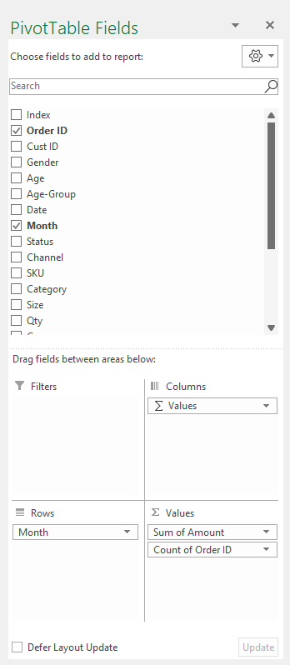

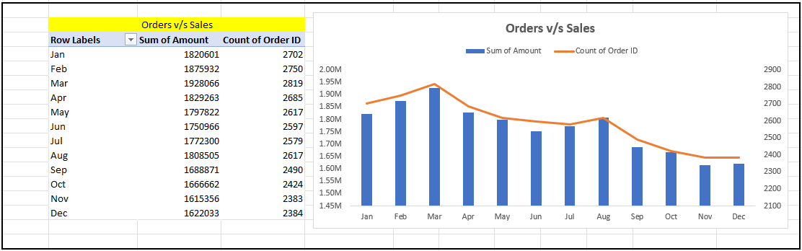

* + PivotTable 2, Chart 2 :- “Sales :- Men v/s Women”

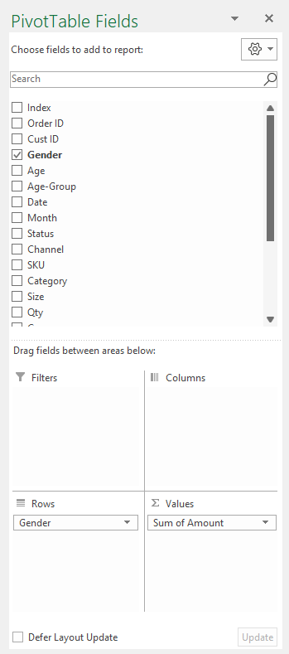

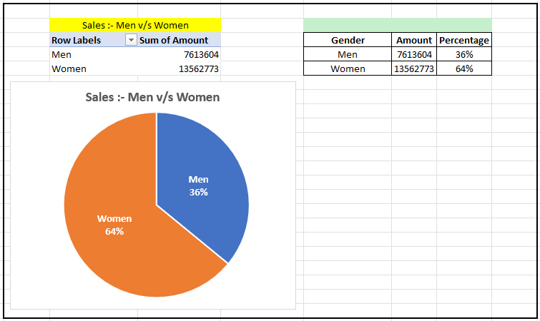

* + PivotTable 3, Chart 3 :- “Order Status”

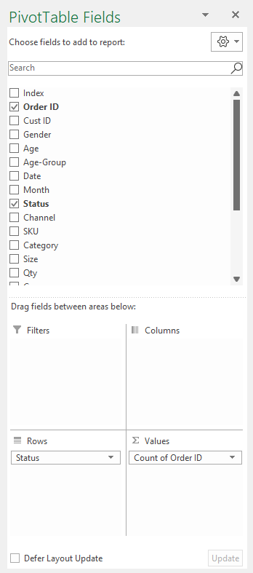

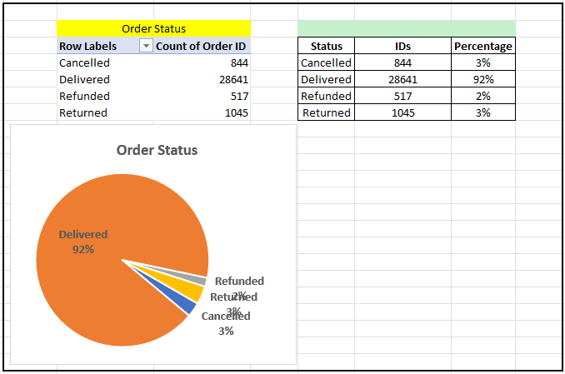

* + PivotTable 4, Chart 4 :- “Sales :- Top 10 States”

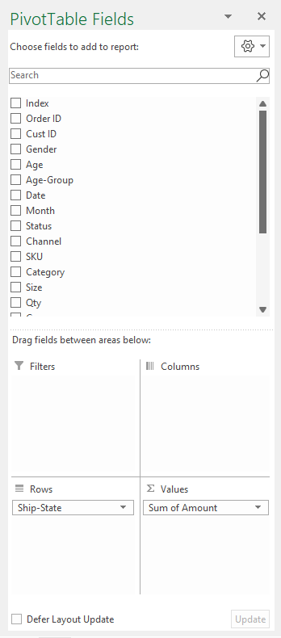

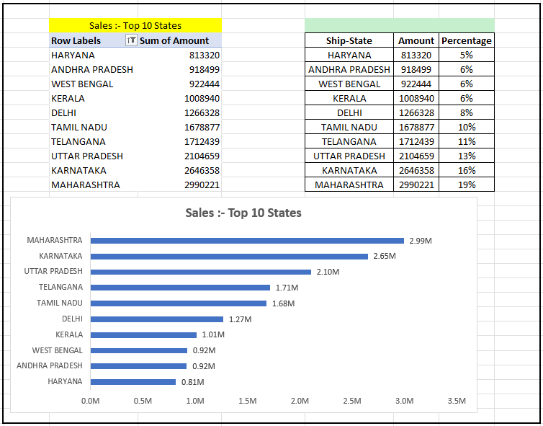

* + PivotTable 5, Chart 5 :- “Orders :- Age v/s Gender”

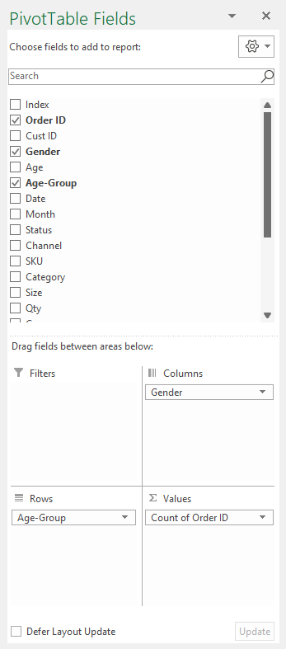

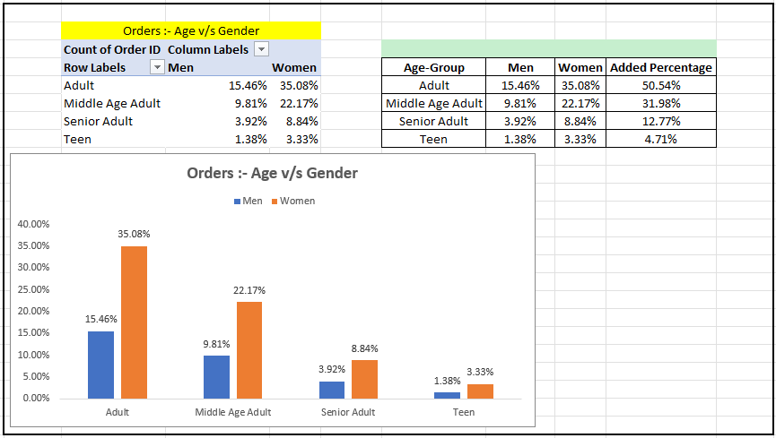

* + PivotTable 6, Chart 6 :- “Orders :- Channels”

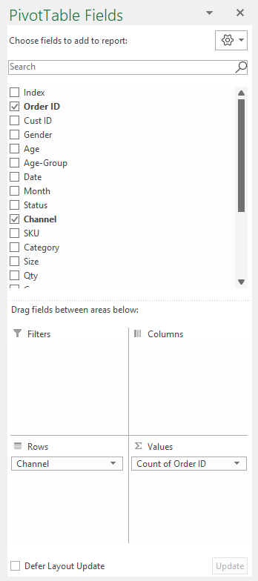

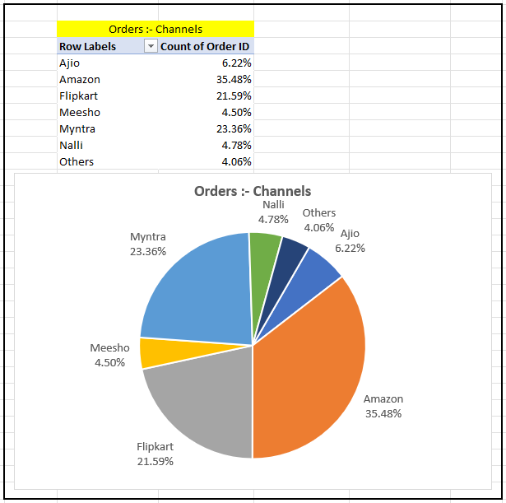

1. Coming to dashboard :-
   * Firstly, removed the gridlines of cells.
   * Then selected black color as an background for the dashboard.
   * Inserted shapes and changed the color of it as per the need
   * Added Text Box in 1st shape.
   * Then inserted the charts into other shapes from “Data Analysis & KPIs” Sheet.
   * Select every chart and gone to “Shape Format” Tab > under “Shape Styles” Section > select “Shape Fill - No Fill” , “Shape Outline - No Outline”
   * Done formatting in all the charts from “Format Plot Area” Pane as per the need.
   * Under “Chart Element” for every chart done formatting as per needed like “removing grid lines, etc.).
   * Inserted “Slicers” by :- select any chart on dashboard worksheet > select “PivotChart Analyze” Tab > under “Filter” Option > select “Insert Slicer” Option.
   * Then select “Month”, “Category”, “Channel” > click on “OK”.
   * Right click on “Month” slicer then select “Report Connections…” > select all pivot tables those are present there > OK. So, that this slicer should be connected to every pivot table present there.
   * Do the same of “Category” slicer & “Channel” slicer.
   * Now select all 3 slicers goto “Slicer” Tab > under “Slicer Styles” Section > select “New Slicer Style…” Option > customize as per your need > OK.
   * Now that cutom style is added to “Slice Style” section, for your future use.
   * Now place all the slicers in their places.
   * Now add one more shape for hyper link sections.
   * Add different icons in it as per the need.
   * Then on every icon to link then with hyperlink.
   * Right click on one icon > select “Link” Option > select under “Link to:” Section, select “Place in This Document” option > then select “Worksheet Name” (then after clicking on that icon you will be redirected to that worksheet) > OK.
   * Repeat this step for all the icons.
   * Then copy and paste that icon’s section in all the worksheets. So, that you can easily move between worksheets with that hyperlink section while giving the Presentation to Stakeholders, Team Leaders, Project Co-coordinators, Project Managers, Mid-Level Managers, Senior-Level Managers, Investors, Lecturers, Guides.
2. Insights OR Conclusion :-

* Insights :-
* Final Conclusion to improve Vrinda store sales :-
  + - In 2022, "March" is the month with highest sales done (19,28,066 i.e. 1.92M).
    - "Women" are more likely to buy compared to men (64%).
    - Most of the items are "Delivered" under order status category which is around (92%).
    - "Maharashtra", "Karnataka", "Uttar Pradesh", "Telangana", "Tamil Nadu" are the top 5 states which is doing the sales of (69%).
    - "Maharashtra", "Karnataka", "Uttar Pradesh" are the top 3 states which is doing the sales of (48%).
    - To sales, Age group "Adult" (20 - 39 years) is max contributing (50%).
    - To sales, Channels "Amazon", "Flipkart", "Myntra" are max contributing (80%).
* Final Conclusion to improve Vrinda store sales :- This will help to improve sales of Vrinda store in 2023
  + - 1. Target "Women" cunstomers of age group (20 - 39 years) living in "Maharshtra", "Karnataka", "Uttar Pradesh" by showing ads/offers/coupons available on "Amazon", "Flipkart", "Myntra".

??